April News

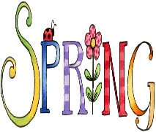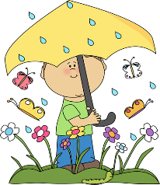

Second Grade April 9 - 13

**MicroSociety News**

Students will be testing on Wednesday and Thursday of this week. Please read the following guidelines:

* Arrive at school on time each of the testing days
* If your child wears glasses, make sure they have them on testing days
* Students should get plenty of sleep the nights before the tests
* Speak to your child about doing their best

Word Study  
*****************************************

**Mrs. Forkum**: Digraphs SH, CH  
**Spelling Words:** chat, such, flash, shift, crush, rich, chill, shop, chop, smash  
**Sight Words:** him, make, like, has, into

*****************************************

**Ms. Taylor**: Long A Digraphs

**Spelling Words:** paid, faint, drain, trail, stay, play, paint, sail, bait, trait

**Sight words:** people, way, write, see, number

****************************************

**Mrs. Ebbert**: Long I Digraphs  
**Spelling Words:** pie, lie, sigh, tie, high, might, slight, light, flight, fright  
**Sight Words:** sit, now, down, find, long

*****************************************

**Mrs. Farley:** Variant Vowel /ôr/  
**Spelling Words**: port, shore, more, roar, door, thorn, porch, short, floor, snore

**Sight Words:** place, years, back, me, live

**This Week’s Focus**

**Reading:** Bigger books mean ramping up reading power.  
**Vocabulary:** urban, suburban, rural, agriculture, symbols, trade, heritage, resources  
**Writing**: Students will continue with letter writing. Students will continue working on contractions. Grammar review over simple/compound sentences, irregular plurals, usage of am, is, are, was, were, have, has, had, correcting sentences.  
**Math:** Students will continue with Module 4: Addition and Subtraction within 200 with Word Problems to 100. They will review arrays, time, measurement, money, shapes, and fractions.  
**Science/Social Studies:** Students will begin a study of Economics – Goods, Services, and Resources.