November News

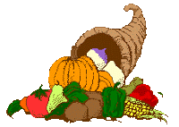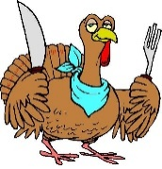

Second Grade November 13 - 17

**MicroSociety News**

* **Picture Day is Wednesday, November 15.**
* **Thanksgiving Break will be November 20 – 24. No school that week.**
* **Friday is Thanksgiving Feast in the cafeteria. You are invited to join your child for lunch. Please fill out the form we sent home and return it as soon as possible so they can have an accurate count for how many will be here. You can also have your picture made. See the note we sent for costs.**

Word Study

*****************************************

**Mrs. Forkum**: Final Consonant Clusters  
**Spelling Words:** band, blend, mint, print, sunk, hang, pond, send, bank, sing

**Sight Words:** this, have, from, or, one

*****************************************

**Ms. Taylor**: Three-letter blends

**Spelling Words:** split, squint, strap, strand, spring, scrub, three, splash, shred, thrill

**Sight words:** what, all, were, your, when

****************************************

**Mrs. Ebbert**: CVCe – Long I  
**Spelling Words:** mine, time, bite, five, drive, hide, glide, hive, ripe, stripe  
**Sight Words:** how, their, if, other, will

*****************************************

**Mrs. Farley:** Long O Digraphs  
**Spelling Words**: boat, goat, snow, grow, toe, bold, goal, scold, loan, mow

**Sight Words:** no, two, my, than, first

**This Week’s Focus**

**Reading:** Students will be “Learning the Lingo of a Topic.”

**Vocabulary:** peaceful, tribe, carve, feast, Pilgrim, celebrate, tradition, colonist

**Writing**: Students will begin working on Informative writing. They will research Native American tribes.

**Math:** Students will continue working on Place Value, Counting, and Comparing of Numbers to 1,000.

**Social Studies:** Students will be learning about timelines.