November News

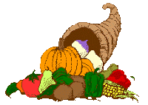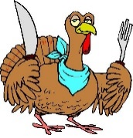

Second Grade November 6 - 10

**MicroSociety News**

* **Picture Day is Wednesday, November 15.**
* **Thanksgiving Break will be November 20 – 24. No school that week.**
* **Please be sure to return the purple Parental Involvement Plan forms as soon as possible.**
* **With the weather turning colder, please be sure that your child is dressed warmly. Please send a coat or jacket with them for recess.**

Word Study

*****************************************

**Mrs. Forkum**: Final s-family blends  
**Spelling Words:** desk, fast, ask, wasp, blast, crisp, grasp, cost, mask, past

**Sight Words:** with, his, they, at, be

*****************************************

**Ms. Taylor**: Three-letter blends

**Spelling Words:** split, squint, strap, strand, spring, scrub, three, splash, shred, thrill

**Sight words:** what, all, were, your, when

****************************************

**Mrs. Ebbert**: CVCe – Long o  
**Spelling Words:** smoke, stole, home, hope, rope, stove, joke, globe, yoke, chrome  
**Sight Words:** use, each, which, she, do

*****************************************

**Mrs. Farley:** Long a digraphs  
**Spelling Words**: paid, faint, drain, trail, stay, play, paint, sail, bait, trait

**Sight Words:** people, way, write, see, number

**This Week’s Focus**

**Reading:** Students will be “Learning the Lingo of a Topic.”

**Vocabulary:** peaceful, tribe, carve, feast, Pilgrim, celebrate, tradition, colonist

**Writing**: Students will begin working on Informative writing. They will research Native American tribes.

**Math:** Students will continue working on Place Value, Counting, and Comparing of Numbers to 1,000.

**Social Studies:** Students will be learning about timelines.