October News

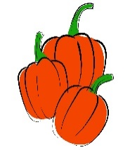

Second Grade October 15 - 19

**MicroSociety News**

* Parent-Teacher Conferences will be Thursday, October 18, from 2:30 – 8:30. We will be sending out notices this week to sign up for a time. Please put your top three choices and send it back as soon as possible. We will fill times on a first come, first serve basis.
* **School will dismiss on Thursday at 1:40 for Parent-Teacher Conferences.**
* No school on Friday. Teachers have a professional development day.

**Word Study**

Students will be studying about the R-controlled vowels AR  
**Feature Words:**park, smart, card, spark, charm, yard, farm, mark, jar, shark **Sight Words:**made, part, over, new, sound

Test on Wednesday

**This Week’s Focus**

**Reading:** Students will become experts reading nonfiction. Thinking Hard and Growing Knowledge.

**Vocabulary:** plant, flower, leaf, stem, roots, petal, seed, pollination  
Test will be next Friday at the end of the unit.

**Writing**: Students will continue working on personal narratives. Students will also work on plural nouns.

**Math:** Students will begin Module 3 – Place Value, Counting, and Comparisons of Numbers up to 1,000

**Science:** Students will begin a two week unit on plants.

