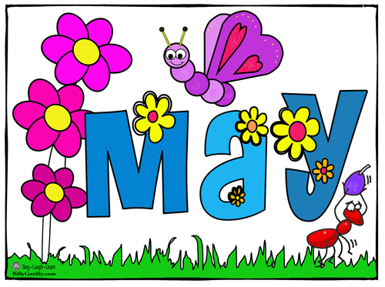

5/8 Family Literacy Night 5:30 – 7:00
5/10 PE Field Day
5/18 PBIS Water Day
5/22 Awards Ceremony 8:30 – 9:00
5/24 Last Student Day

