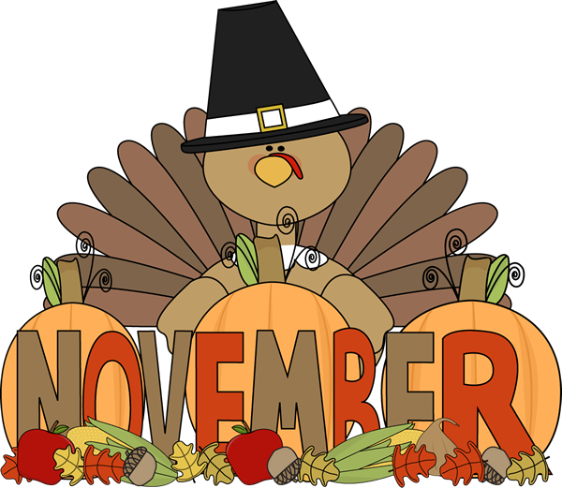

11/15 School Pictures

11/17 Thanksgiving Feast – Parents are
invited to join their child for a
Thanksgiving lunch in the cafeteria.
Pictures will be available for $1.00
for a 4 x 6 and $2 for a 5 x 7. Cost
of lunch is $3.25 for adults and $2.00
for children.

11/20 – 11/24 Thanksgiving Break – NO SCHOOL

