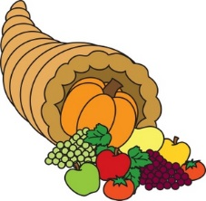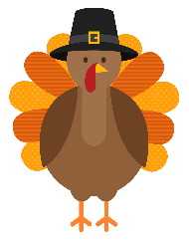
November News
Second Grade October 29 – November 2

MicroSociety News

- Be sure to bring your $3 for the party on Wednesday. We need this no later than Tuesday.
- Students may dress up as book characters for Wednesday.
- NO HALLOWEEN COSTUMES.

Word Study
Students will be studying about the R-controlled vowels ER
Feature Words:
circle, stir, skirt, firm, bird, girls, chirp, birthday, dirty, thirty
Sight Words:
people, nice, went, every, use

Test on Friday

This Week’s Focus
Reading: Students will become experts reading nonfiction. Thinking Hard and Growing Knowledge. Comprehension Test Friday.

Vocabulary: plant, flower, leaf, stem, roots, petal, seed, pollination
Test will be Friday at the end of the unit.
Writing: Students will continue working on personal narratives. Students will also work on plural nouns.

Math: Students will continue with Module 3 – Place Value, Counting, and Comparisons of Numbers up to 1,000. Test over Lessons 4 – 7 on Friday

Science: Students will continue our unit on plants.

Vocabulary Words
Plant – a living thing that has roots and cannot move from place to place. They make their own food.
Flower – attracts pollinators and creates seeds to produce new plants.
Leaf – a flat part of a plant that usually grows off the stem. Makes food for the plant through photosynthesis.
Stem – the part of a plant that supports the leaves, fruit, or flowers.
Roots – a plant part that grows down into the soil. They absorb nutrients and water for the plant.
Petal – a brightly colored part of a flower.
Seed – the first stage in a plant’s life cycle. All plants grow from seeds.
Pollination – the process by which pollen is moved from the stamen to the pistil of a flower by a pollinator.

